Classification of Polarization  Light in the form of a plane wave in space is said to be linearly polarized. Light is a transverse electromagnetic wave, but natural light is generally unpolarized, all planes of propagation being equally probable. If light is composed of two plane waves of equal amplitude by differing in phase by 90°, then the light is said to be circularly polarized. If two plane waves of differing amplitude are related in phase by 90°, or if the relative phase is other than 90° then the light is said to be elliptically polarized.  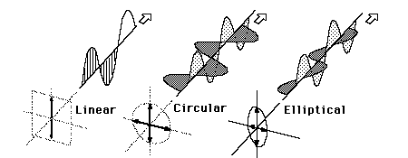 | Index  Polarization concepts
  Methods for achieving polarization
 | Go Back
  HyperPhysics***** Light and Vision | R Nave

Linear Polarization  A plane electromagnetic wave is said to be linearly polarized. The transverse electric field wave is accompanied by a magnetic field wave as illustrated.  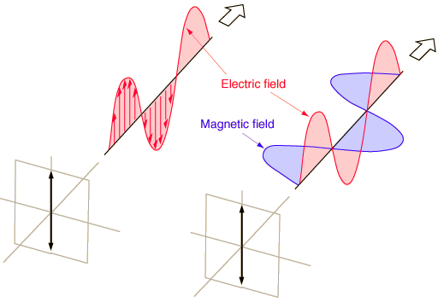 | Index  Polarization concepts
  Compare with circular and elliptical polarization
 | Go Back
  HyperPhysics***** Light and Vision | R Nave

Circular Polarization  Circularly polarized light consists of two perpendicular electromagnetic plane waves of equal amplitude and 90° difference in phase. The light illustrated is right- circularly polarized.  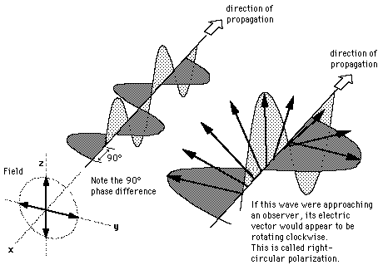  If light is composed of two plane waves of equal amplitude but differing in phase by 90°, then the light is said to be circularly polarized. If you could see the tip of the electric field vector, it would appear to be moving in a circle as it approached you. If while looking at the source, the electric vector of the light coming toward you appears to be rotating clockwise, the light is said to be right-circularly polarized. If counterclockwise, then left-circularly polarized light. The electric field vector makes one complete revolution as the light advances one wavelength toward you.  Circularly polarized light may be produced by passing linearly polarized light through a quarter-wave plate at an angle of 45° to the optic axis of the plate. | Index  Polarization concepts
  Compare with linear and elliptical polarization
 | Go Back
  HyperPhysics***** Light and Vision | R Nave

Elliptical Polarization  Elliptically polarized light consists of two perpendicular waves of unequal amplitude which differ in phase by 90°. The illustration shows right- elliptically polarized light.  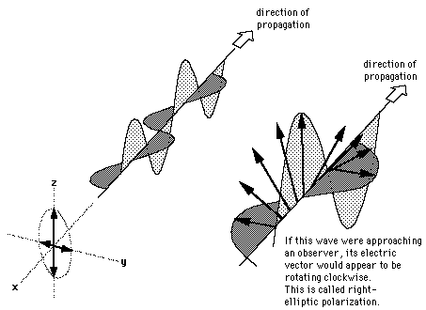 | Index  Polarization concepts
  Compare with linear and circular polarization
 | Go Back
  HyperPhysics***** Light and Vision | R Nave

